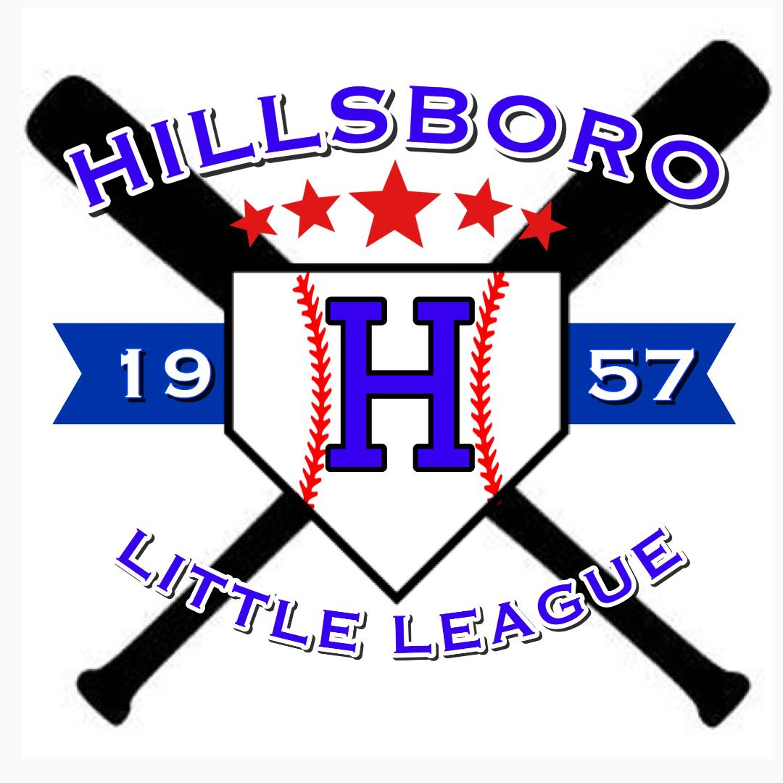
Hillsboro Little League ∙ PO Box 311, Hillsboro, MO 63050

Sponsorship Contract
Please complete the form below. You may choose to participate in more than one sponsorship opportunity.

__________ League Donation – Any Amount
All donations are greatly appreciated
__________ Base Hit - $140.00
Scholarship sponsor – All monies donated to this fund pay for those children whose families cannot afford the registration fee and receive recognition on the Hillsboro Little League website.
__________ Double - $200.00
All monies donated to this fund will receive recognition on the Hillsboro Little League website and a Hillsboro Little League Sponsorship plaque.
__________ Triple - $300.00
All monies donated to this fund will receive recognition on the Hillsboro Little League website, a Hillsboro Little League Sponsorship plaque, and the sponsor’s name on the back of a team’s uniform.
__________ Home Run - $400.00
All monies donated to this fund will receive recognition on the Hillsboro Little League website, a Hillsboro Little League Sponsorship plaque, and the sponsor’s name on the back of a team’s uniform, and a field sign.
__________ Grand Slam - $500.00
All monies donated to this fund will receive recognition on the Hillsboro Little League website, a Hillsboro Little League Sponsorship plaque, and the sponsor’s name on the back of a team’s uniform, and a sign on the roof of the pavilion at the concession stand (visible from Hwy BB).
__________ Product/Service Donation
I have a company that can offer a service or product to help the League (i.e. a Bobcat service, a tree-trimming company, rock/sand/dirt, etc.)

Thank you again for helping make a difference in our Hillsboro Little League Community

Company Name _____________________________________________________________
Contact ________________________________ Number __________________________
Address ____________________________________________________________________
Email ______________________________________________________________________
Amount Enclosed __________________ (Cash/Check)
Team/Child Sponsored (if applicable) ____________________________________________

PLEASE REMIT BY APRIL 1 to P.O. Box 311, Hillsboro, MO 63050
*We are happy to accept sponsorships at any time, however we cannot guarantee your sign will be ready for Opening Day if submitted after April 1*

Please email artwork for website recognition and signs to hillsboromoll@gmail.com by April 1

